Deliverable Phase II
Introduction:-
Welcome to FastByte, a lightweight food-ordering and restaurant management system. Phase 2 of the FastByte project focuses on completing the authentication workflow, linking frontend to backend, and building the restaurant dashboard foundation. Since the scope remains mostly the same as Phase 2 in Deliverable-2, we keep the same requirement set but rewrite them in more detailed, implementable form.
Use-Case Diagram:-
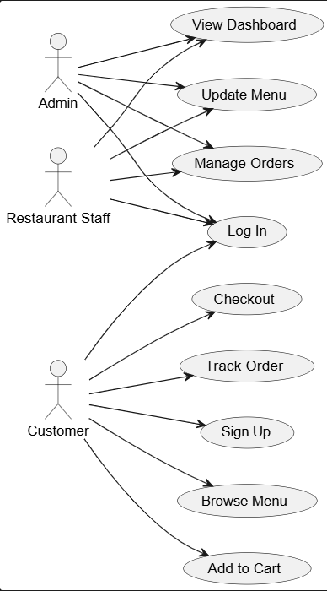

Class Diagram:-
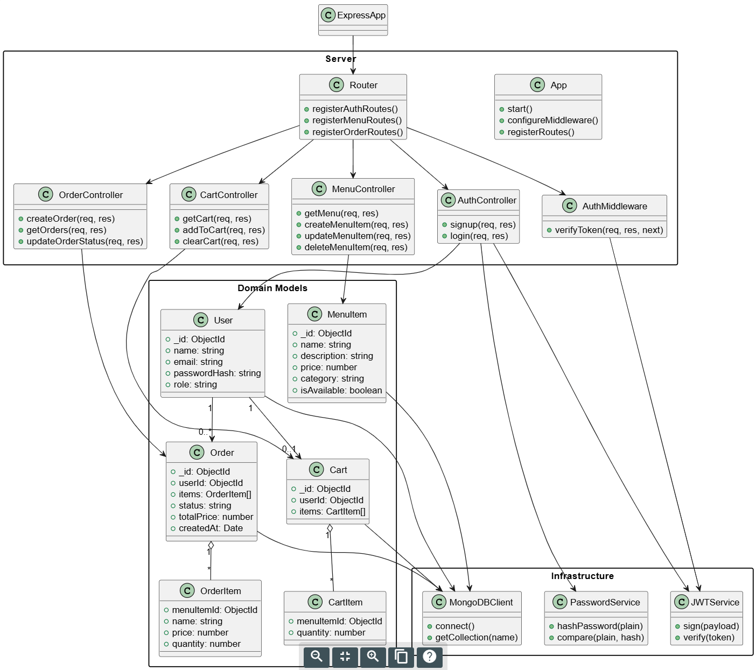

Sequence Diagram:-
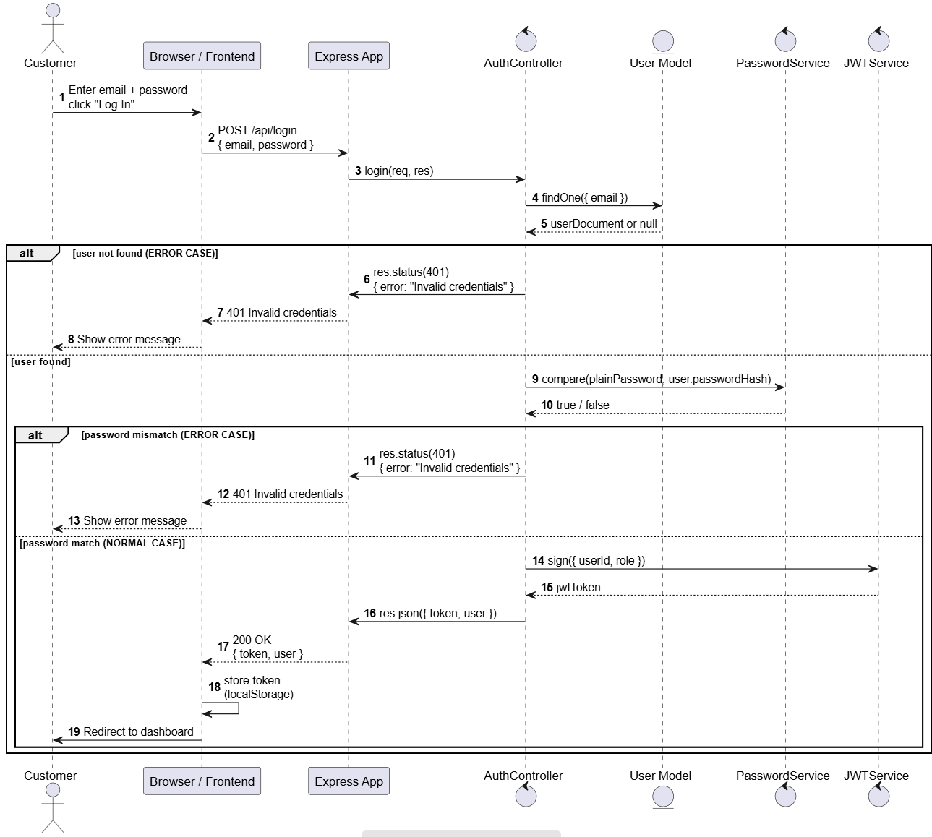

User Manual
- Customers can create an account by selecting “Sign Up”, entering their name, email, and password, and submitting the form.
- After signing up, customers log in using their email and password on the main login page.
- Once logged in, customers are taken to the Menu Page, where they can view a list of available food items with names and prices.
- Customers can click “Add to Cart” to add items, though the cart is only partially functional in this phase.
- Restaurant staff and admins also log in through the same login page using their credentials.
- After successful authentication, staff/admin are redirected to the Restaurant Dashboard.
- The Dashboard includes a static sidebar, a layout for menu management, and an Orders section showing a static list of orders and sample statuses.
- These dashboard features act as placeholders for future dynamic functionality such as real-time order management and menu editing.
- If a logout option is available, users may select it to end their session; otherwise, closing the browser or clearing local storage will log them out manually
- Current system limitations include a basic cart, static dashboard pages, and no checkout or dynamic order updates.

To Compile/Run:-
Prerequisites:-
- Node.js and npm installed
- MongoDB URI
- .env file with MONGO_URI, JWT_SECRET in the project root

Steps:-
- Go to the project root
- Run “npm install” in terminal
- Run “npm nun dev” in the same terminal
- Go to:- https://localhost:5173
Test Cases:-
Functionality | EndPoint | Input | Expected Output | Description
Signup – success | POST /api/signup | Valid name, email, password | 201 + JSON {user, message} | Verifies new user can register and is stored with hashed password
Signup – duplicate email | POST /api/signup | Email already in DB | 400 + {error: “Email already in use”} | Ensures backend rejects duplicate emails
Login – success | POST  /api/login | Valid email + password | 200 + {token, user} | Confirms valid user can log in and receives JWT token
Login – wrong password | POST  /api/login | Valid email, wrong password | 401+ {error: “Invalid Credentials”} | Tests error path when user enter incorrect password
Login – unknown email | POST  /api/login | Email not in DB | 401 + {error: “Invalid Credentials” | Tests error path when user does not exists

Code Inspection:-
During the code inspection session, the other group went over our code and did not find any significant errors or things to improve upon. However, in order to prevent errors in the code and/or rendering errors, we reviewed and checked the syntax of our pages and also updated links to use prefetching to help performance of client-sided navigation.

Reflection:-
- Accomplishment:- Integrated frontend-backend API routing connections for authentication, Restaurant Dashboard Structure, Auth routes validated and workings
- What went well:- Team communication improved, No major merge conflicts
- What could be improved:- Need to implement backend to assign and designate drivers, dynamic API data in Restaurant Dashboard, Code and implementation review, component and integration testing.

Member Name | Contribution Description | Overall Contribution
Roger Lin | Code refactoring, bug and styling fixes, and sign up page | 25%
Aayush Niroula | Implemented Backend functionalities with remaining API endpoints | 25%
Neel Panajkar | Implemented Cart and Dashboard as needed | 25%
Kaksh Patel | Handled Presentation based on the changes made to the project | 25%

